Machine Learning Report

Project Progress
Week 1 and Week 2 – Learning the concepts of python such as functions, file handling, Object oriented programing, numpy and pandas.
Practising question on the concepts and trying to becoming use to using them.
Learning theory of linear regression and trying to build logic to implement the regression in python.
Implementing linear regression of single variable to build logic to implement multi variable linear regression.

Week 3 – Implementing multivariable Linear regression.
Trying to implement polynomial regression.
Applying different features scaling and finally settling to use mean normalization in the linear regression to minimise the cost.
Learning the concepts of Logistic regression and implementing binary logistic regression in python.
Week 4 – Implementing multinomial logistic regression using the algorithm one vs rest.
Using feature engineering and feature scaling to enhance the polynomial regression.
Implementing multinomial logistic regression using softmax regression.
Learning the concepts of neural network and implement forward propagation in python.
Trying to implement linear regression using OOPS.
Learning and trying to implement backward propagation in neural network.

Linear Regression:-
Linear regression is implemented with mean normalisation and with learning rate = 2 and after 250 iterations the value of cost is 4769.85
The variation of cost with iteration(cost on y-axis)
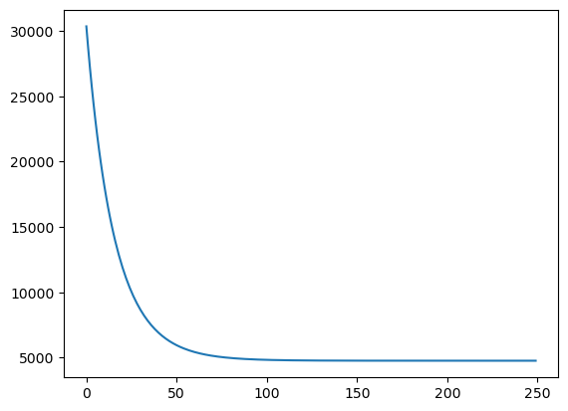
Polynomial Regression:-
Polynomial Regression is implemented with Z – score normalisation and with features engineering. With features engineering a four quadratic is made. By keeping learning rate = .25 and 170 iterations the cost is 3.482e+11.
The variation of cost with iteration(cost on y-axis) 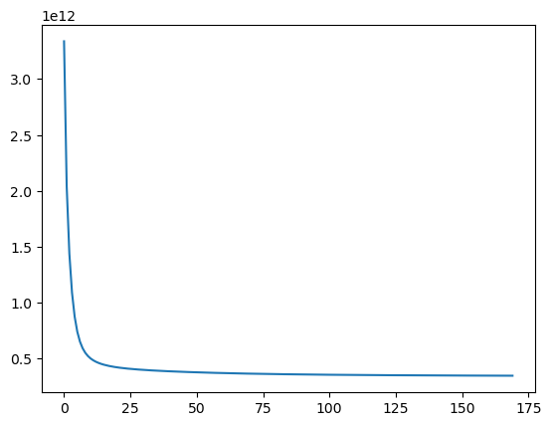
Logistic regression:-
Logistic regression is implemented by using both one vs rest and softmax regression algorithms. After splitting the train data into 80 and 20 percent and training the model on 80 percent of train data and testing the model on rest 20 percent of data the accuracy came out to be 66.08% with softmax regression on learning rate = .8 after 20 iterations and 77.03% with one vs rest regression on learning rate = .006 after 250 iterations.

About me:-
Name – Raman Sharma
Addmission number – 22JE0775
Discipline – Civil Engineering
College – IIT(ISM) Dhanbad
Address – Gorakhpur, Uttar Pradesh
Contact number – 9005381800
Email ID – iiscramansharma@gmail.com

